**ICIN Bank**

**Capstone Project**

Here are some of the screenshots of the execution of the project

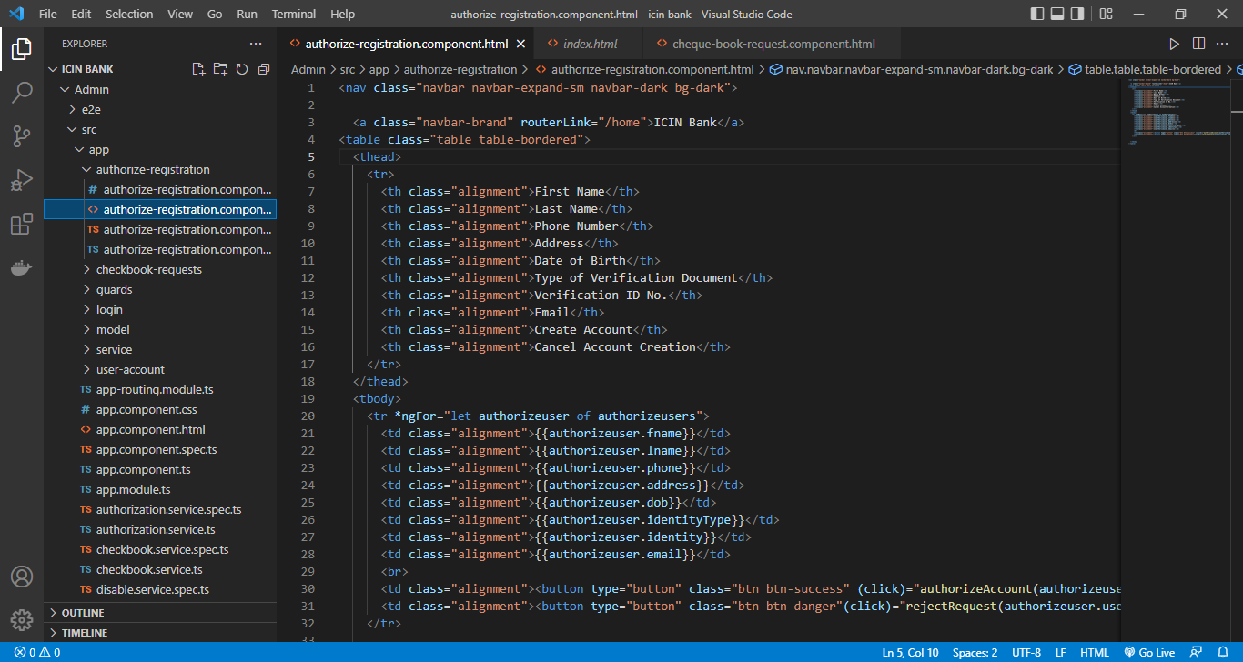

Here we created the two users admin and users

Hers is the home page of the bank

In the front end application in visualstudio we have done the authorized registry

In the Backend application in Eclipse we have done the bank admin server user server and done the selenium testing by test ng

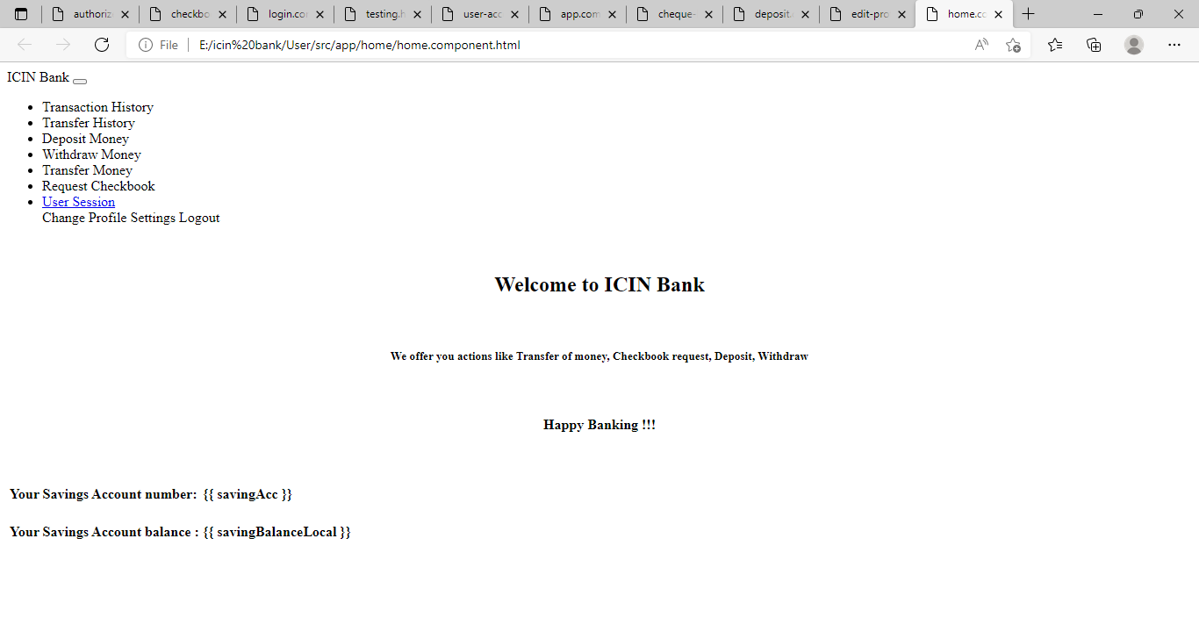

Here is the user registration portal

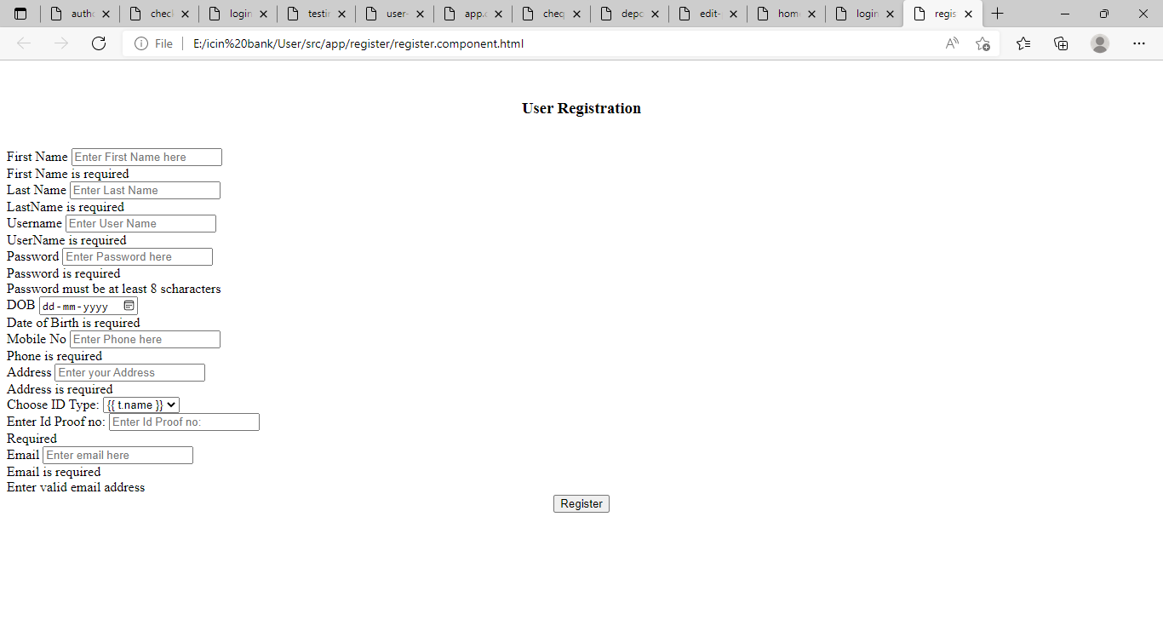

Here is the user login portal

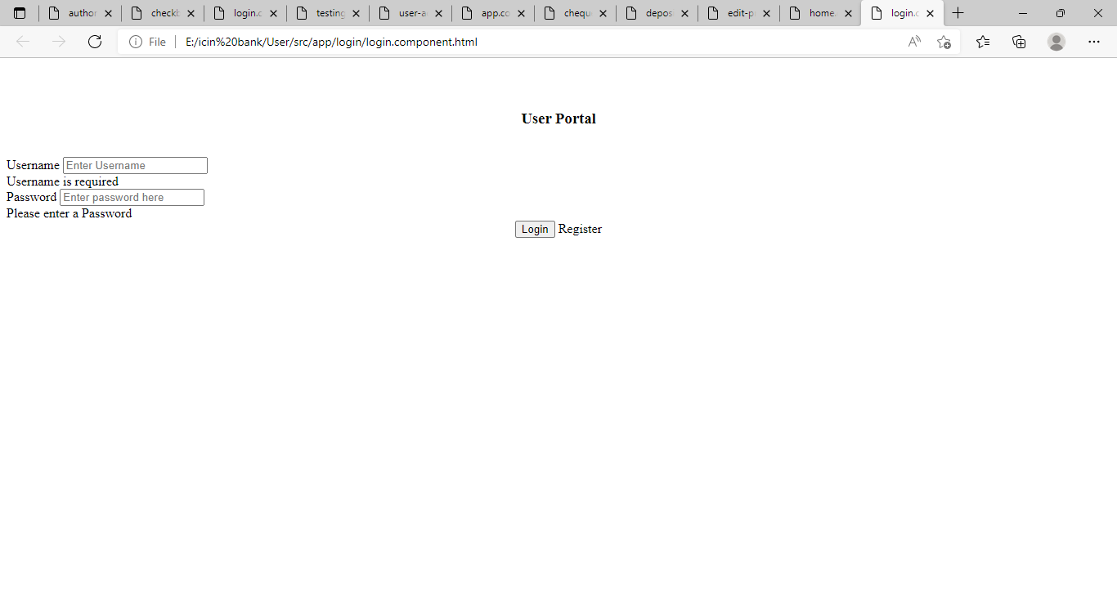

Here is the admin login portal

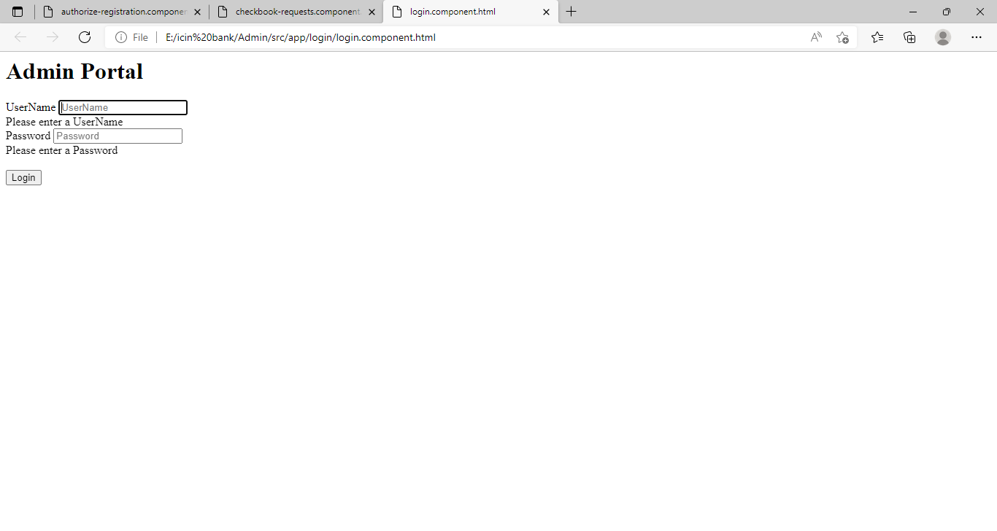

Here is the admin conformation page of Registration

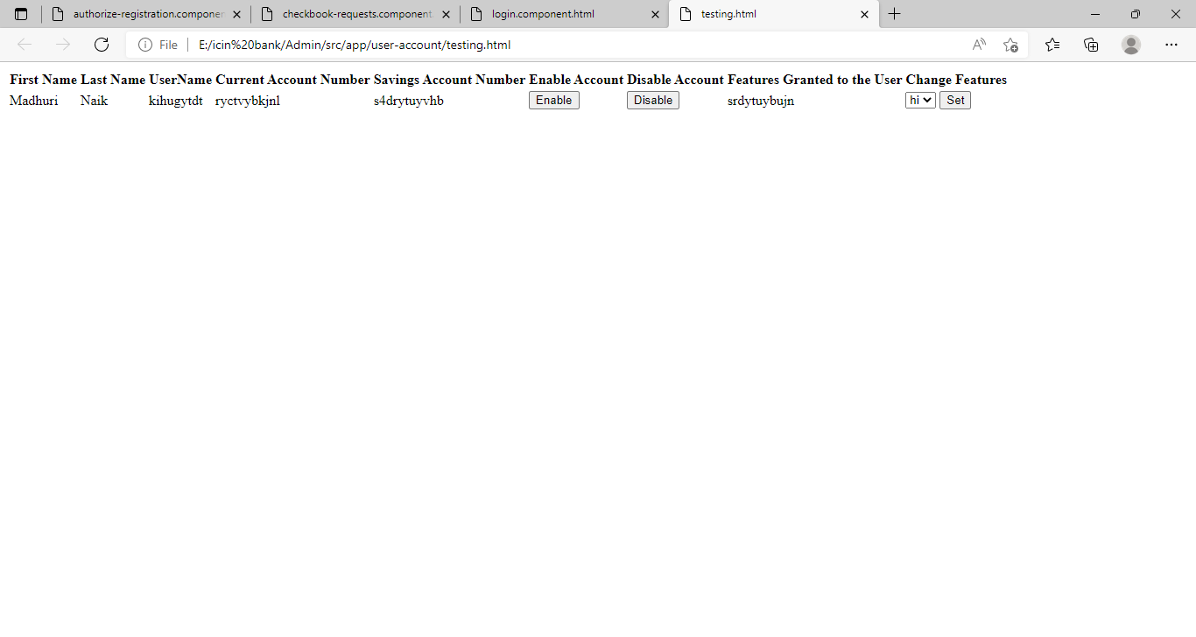

Here is the cheque book request portal

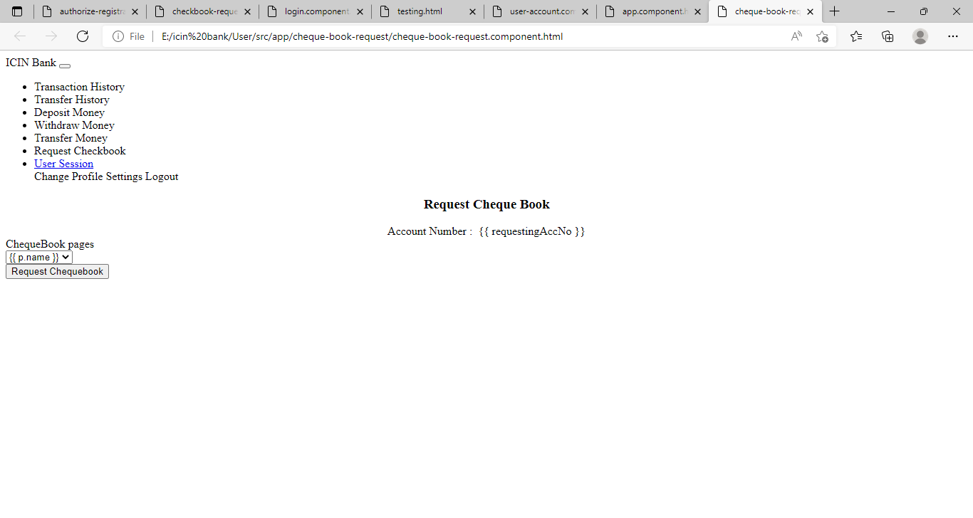

Edit profile

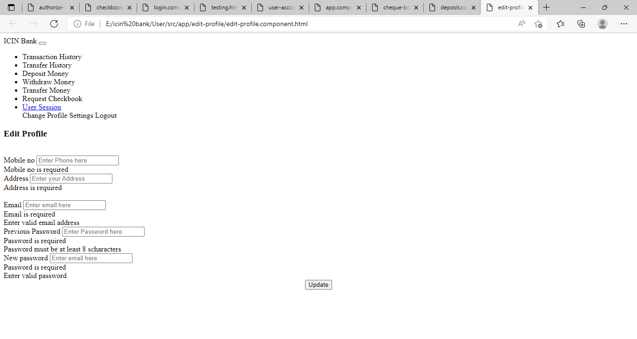

Transcation history

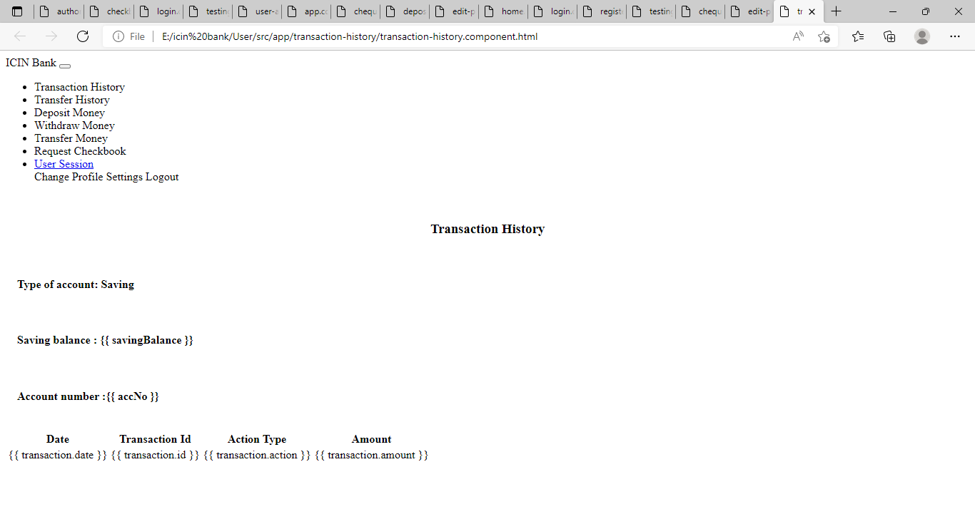

Transfer history

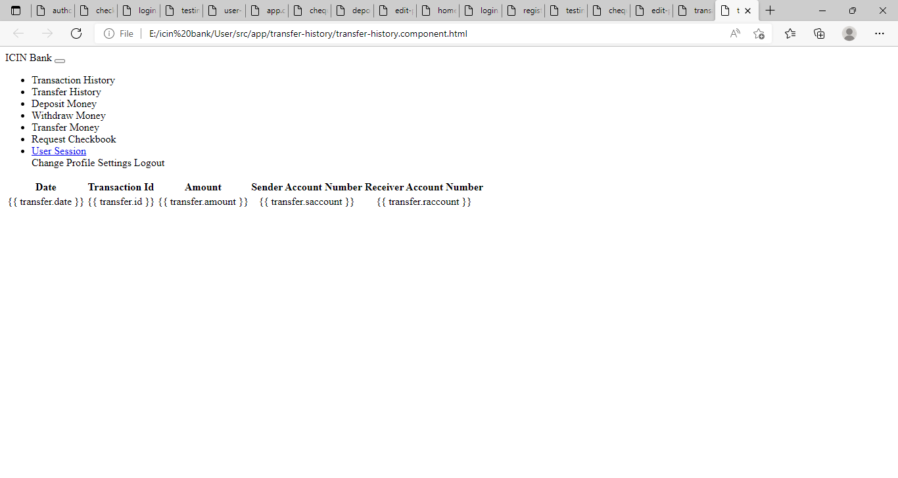

Here is the withdrawl portal

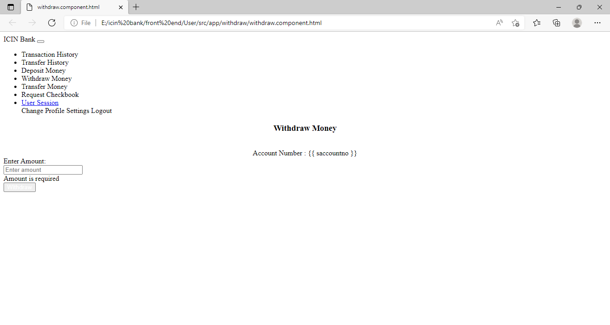

Here is the screenshots of Selenium testing test ngresults

